**Assignment 2**

**Submitted by: Nitin Kumar**

Sol 1: //Write a program to calculate the sum of first 10 natural number.

**package** practiceLAB1;

**public** **class** Q1SumOfFirstTenNos

{

**public** **static** **void** main(String[] args)

{

**int** i; **int** num = 0;

**for**( i=1; i<=10; i++ )

{

num=num+i;

}

System.***out***.println("The sum of number is " +num);

}

}

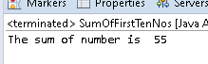

Sol 2: package practiceLAB1;

/*Write a program that prompts the user to

* input a positive integer. It should then print

* the multiplication table of that number.

*/

import java.util.*;

public class Q2MultiplicationOfANumber

{

public static void main(String[] args)

{

Scanner s=new Scanner(System.in);

System.out.println("Enter The Number");

int a=s.nextInt();

if(a>0)

{

System.out.println("Number is positive");

}

for(int i=1; i<=10; i++)

{

int k=a*i;

System.out.println(k);

}

}

} 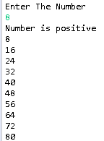

Sol 3: /*Write a program that prompts the user to input an integer and

* then outputs the number with the digits reversed. For example,

* if the input is 12345, the output should be 54321.

*/

**package** practiceLAB1;

**public** **class** Q3ReverseNumber

{

**public** **static** **void** main(String[] args)

{

**int** n=12345;

**while**(n!=0)

{

System.***out***.print(n%10);

n=n/10;

}

}

}

